**Artificial Intelligence and Data Science Department.  
Computer Networks / Even-Sem 2021-22 / Experiment 6.  
_________________________________________________________________**

**YASH SARANG.  
47 / D11AD.  
EXPERIMENT - 6.  
_________________________________________________________________**

**Aim:**

To design and simulate the environment for Dynamic routing using Cisco packet tracer/ GNS3.

**_________________________________________________________________**

**Theory:**

1. Packet Tracer is a cross-platform visual simulation tool designed by Cisco Systems that allows users to create network topologies and imitate modern computer networks.
2. The software allows users to simulate the configuration of Cisco routers and switches using a simulated command line interface.
3. Packet Tracer makes use of a drag-and-drop user interface, allowing users to add and remove simulated network devices as they see fit.
4. Packet Tracer can be run on Linux, Microsoft Windows, and macOS. Similar Android and iOS apps are also available.
5. Packet Tracer allows users to create simulated network topologies by dragging and dropping routers, switches, and other network devices.
6. A 'cable' item represents a physical connection between devices.
7. Packet Tracer supports an array of simulated Application Layer protocols and basic routing with RIP, OSPF, EIGRP, BGP, etc.
8. Packet Tracer allows students to design complex and large networks, which is often not feasible with physical hardware, due to costs

**_________________________________________________________________**

**Output:**

Sending a Packet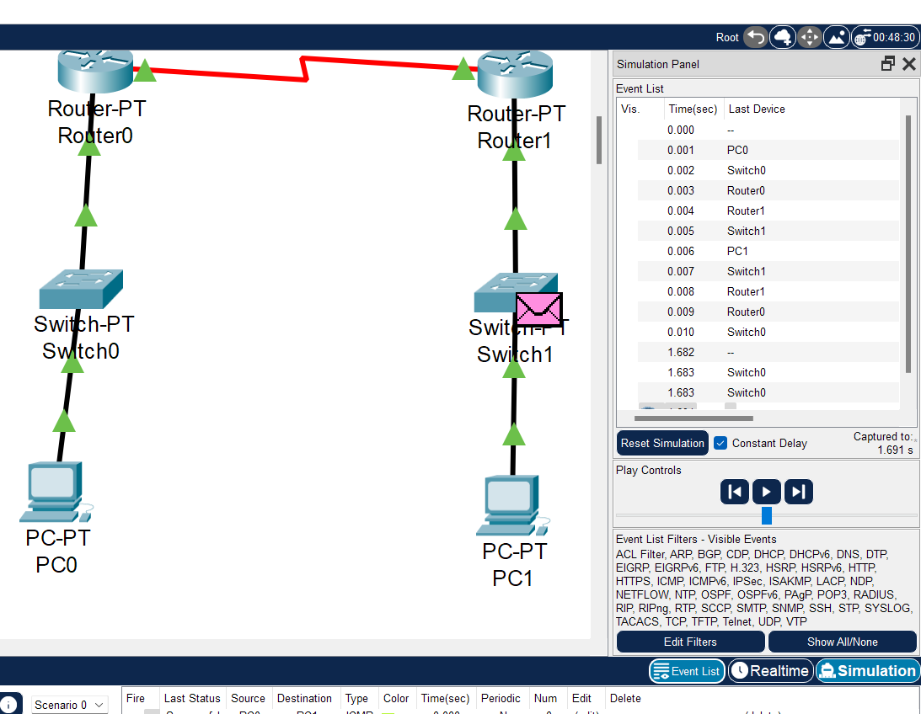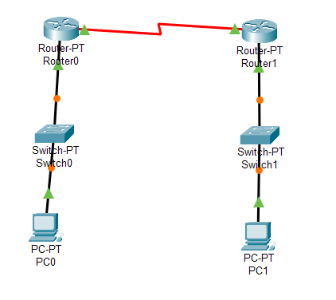

**_________________________________________________________________**

**Conclusion:**

We have studied, learned, and successfully implemented Dynamic routing using a Cisco packet tracer.

**_________________________________________________________________**

**\*\*\*\*\***